FALCONRY EXHIBITION & CELEBRATION IN THE EUROPEAN PARLIAMENT
9 NOVEMBER 2012

Falconers and fellow hunters from 19 countries gathered with EU decision-makers at the European Parliament in Brussels to launch a unique exhibition: the IAF (International Association of Falconry) and FACE joined with European Parliament's Sustainable Hunting Intergroup President, Véronique Mathieu and MEP Bogdan Marcinkiewicz to host an internationally themed visual display at the very heart of Europe.
Building on the 2011 celebrations following falconry’s inscription to UNESCO as a Cultural Heritage of Humanity, the exhibition and activities surrounding the inaugural cocktail reception raised the profile of falconry in the EU – and of course, the profile of hunting as artistry.
THE EXHIBITION: 6-9 NOVEMBER
This unique international exhibition brought together various displays of images, falconry equipment, tools, books and historical artifacts to convey the deep artistry at the heart of this global cultural heritage. Leading falconry experts from the International Association for falconry were on hand throughout the week to provide additional insights into this tradition that is over 4000 years old and practiced all over the world today.
The materials provided by the Coordinating Team from the International Association of Falconry blended the old with the modern in such a way that the exhibition attracted a high footfall of some 200 people every day throughout the week.
THE INAUGURAL RECEPTION
A special photo opportunity for the MEPs and officials with falcons and hawks outside the main entrance of the European Parliament on Brussels Place du Luxembourg attracted great interest as passing EU officials and decision-makers were mesmerised by the unusual sight of these breath-taking birds.
This remarkable scene was heightened by the internationally renowned musical group of traditional Jagdhorn players from the Czech Falconers’ Club - Klub Sokolníku – who called the guests into the inaugural cocktail reception.
Jac van Gerven, hoodmaker gave a demonstration of artisan hood-making and a short film Falconry our Intangible Living Heritage provided an outline of this UNESCO-recognised heritage of humanity.
French MEP Véronique Mathieu & Polish MEP Bogdan Marcinkiewicz both gave welcoming inaugural addresses and were joined by the Parliament’s President of the Culture & Education Committee, Doris Pack.
FACE Vice President Giovanni Bana and Secretary General Angus Middleton both gave a few words on the importance of culture in hunting, and Angus recognised the great contribution of outgoing IAF President Frank Bond who also addressed the assembly.
The Association of Birdsong Imitators was present, providing a brief insight into this enchanting skill. Hundreds of guests fell silent when former world champion Lionel Long and his colleagues from the Association gave a remarkable demonstration of yet another cultural aspect of hunting, imitating song thrushes and blackbirds with astonishing authenticity.
As part of the traditional November hunters’ celebrations, fine game meat from Poland was provided by Member of the European Parliament Bogdan Marcinkiewicz, joined by a representative from the Polish Hunters’ Federation.
With such a fine culinary addition, the reception was very well attended, with some 500 guests lured by the eye-catching exhibition – made even more alluring by the presence of falcons and hawks within the exhibition space. The unprecedented permission of live animals within the Parliament was made possible thanks to the combined efforts and passion of the organisers behind MEP Véronique Mathieu.
***ENDS***
NOTES FOR EDITORS
PHOTOS - http://www.flickr.com/photos/face_eu/sets/72157631961164913/
19 PARTICIPATING COUNTRIES
- Italy
- Netherlands
- Pakistan
- Poland
- Romania
- Slovakia
- Spain
- Switzerland
- United Kingdom
- United States

- Austria
- Belgium
- Croatia
- Czech Republic
- Denmark
- France
- Germany
- Greece
- Ireland

BACKGROUND
Falconry is the art of hunting with trained birds of prey, born out of ancient local tradition around the world and recognised today as a global cultural phenomenon that is present everywhere. It has played a pivotal role in multiple facets of our culture (see benefits of falconry below). The beauty and benefits of falconry have often been unseen, underestimated and misunderstood, many seeing it as a contentious activity. It is hard not to be filled with awe for falconry: the image of a falconer in perfect harmony with his bird encapsulates the great complicity between the two. Falconry glows with potential for our future, an unbroken thread of culture that binds man to his natural world.
November 2010: Falconry’s official inscription at UNESCO’s 5th Intergovernmental Committee meeting that took place in Nairobi, Kenya is an immense achievement for a tradition that is over 4000 years old and encompasses the largest ever nomination in the history of the UNESCO convention, presented by 11 nations.
January 2011: To recognise the endeavours of the falconry community, the International Association for Falconry and FACE joined together with the European Parliament’s Sustainable Hunting Intergroup to host the Falconry – a hunting culture colloquium at the heart of Europe. 2011 was a series of celebrations, starting in Europe with this event and ending in December with thousands of falconers assembling in Abu Dhabi for the International Falconry Festival.

BENEFITS OF FALCONRY
Language: There are a thousand falconry words in common language, some common to many languages. For example: even the universal term 'gentleman' is derived from falconry vernacular implying a man who could fly a female peregrine, the 'falcon gentle'.
Diplomacy: Wars have even been avoided and stopped by diplomatic gifts of falcons.
Safety: Flights out of major airports are protected by falconers who prevent bird strikes and save human lives.
Knowledge of the natural world: Falconers gave the world the first scientific book on nature De arte venandi cum avibus.
Conservation: Falconers have been instrumental in the worldwide recovery of the endangered peregrine falcon and are involved in many conservation projects. See The Peregrine Fund www.peregrinefund.org
Sustainability: Falconry is considered a low-impact activity; falconers understand that their hawks and quarry species must be preserved and have been practicing ‘sustainable use’ for centuries.
Universality: Falconers share universal principles. The same methods of training and caring for birds, the equipment used and the bonding between man and the bird are found throughout the world. It is these common shared traditions and knowledge that make falconry universal and keep it alive, even though these traditions may differ from country to country.

EXTRACT FROM UNESCO SUBMISSION - "Falconry is one of the oldest relationships between man and bird, dating back more than 4000 years. Falconry is a traditional activity using trained birds of prey to take quarry in its natural state and habitat. It is a natural activity because the falcon and her prey have evolved together over millions of years; their interaction is an age-old drama. The falcon is adapted to hunt the prey, and the prey has evolved many ways to escape from the falcon. This leads to a fascinating insight into the way nature works and poses an intellectual challenge to the falconer in his understanding of behaviour. His task is to bring the actors together on nature’s stage. To do this the falconer must develop a strong relationship and synergy with his bird."

ORGANISERS

The European Parliament’s Intergroup “Sustainable hunting, biodiversity, countryside activities and forestry” – the Sustainable Hunting Intergroup is a unique political platform. The President is MEP Véronique Mathieu. An official body of the European Parliament, it is an expert group that brings together MEPs from different political groups to discuss a common topic. The Sustainable Hunting Intergroup was created in 1985 and is one of the oldest and biggest (most number of MEPs) in the Parliament. Since then, it has consistently attracted interest and impact with its debates and events.
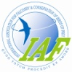The International Association for Falconry and Conservation of Birds of Prey (IAF) is dedicated to the preservation of the ancient art of falconry. Preserving falconry involves maintaining not only the traditional culture that builds practical skills of empathy with animals, but also the conservation of raptors and their prey through preservation of natural habitats. We therefore encourage falconry within the context of sustainable use of wildlife. The IAF is made up of 70 associations in 50 countries worldwide totalling 30,500 Members. www.iaf.org
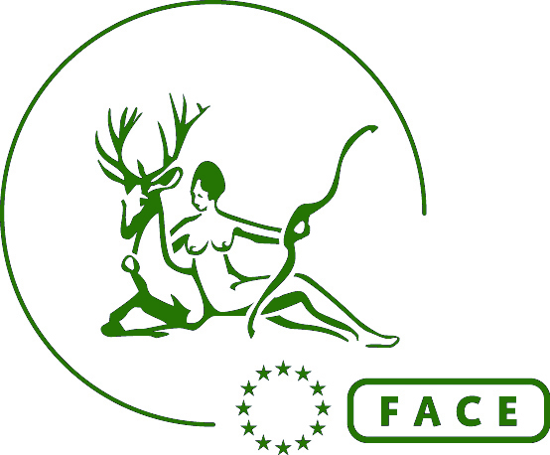 FACE (Federation of Associations for Hunting and Conservation of the EU) represents and promotes the interests of over 7 million European hunters in accordance with sustainable use of wildlife. It is an international non-profit making NGO whose Members are the national hunters' associations within 36 states of the Council of Europe, including the EU27, as well as 4 Associate Members. www.face.eu

For further information please contact:
Marilise Saghbini, Communications Manager marilise.saghbini@face.eu - +32 2 732 6900

